Abstract—Large-scale cluster scheduling/management systems are becoming a dominant platform for a variety of applications and services. These complex “cloud” systems often run on clusters of thousands of unreliable commodity machines and mush handle all kinds of failures, schedule and deployment requirements while achieving the maximum resource utilization. We take YARN to a full analysis and argue that YARN currently excels in handling batch jobs without interacting with outside system or clients. In this paper, we propose a solution to the service registration, rolling upgrade, node relocation problem that YARN had and accommodate YARN to the long-lived services.
Accommodate Apache YARN to long-lived services
Huiyi Li, Shanghai Jiaotong University
Keywords-Component; cluster management; service registration;

Introduction
Large-scale cluster scheduling/management systems [1, 2, 3, 4, 5] are becoming a dominant platform for a variety of applications and services. These complex “cloud” systems often run on clusters of thousands of unreliable commodity machines and mush handle all kinds of failures, schedule and deployment requirements while achieving the maximum resource utilization.
These systems all have two similar interests: improve cluster resource utilization and achieve auto deployment of service. In big data era, our data center usually runs multiple types of applications and servers simultaneously. Such as offline/stream/iterative computing job, web server, database server. Typically we dedicate a unique cluster to each type of services, but due to different resource requirements of different types of services, the resource utilization rate may vary differently. Some cluster may runs at a full capacity and some not. Therefore, resource management systems such as YARN, Mesos, Borg, Omega, Corona, Torca are designed to address this problem.
We take YARN to a full analysis and argue that YARN currently excels in handling batch jobs without interacting with outside system or clients. It takes a job and determines where the components such as Mapper and Reducer would live and deploy those components to different nodes to do their work. But when a long-lived services such as HBase [9], Storm [10], Spark [11, 12] appears, YARN has problem of telling the outside system where those services exists and how to interact with them. When a node becomes unavailable, YARN simply reschedule the component on that node to another one, this was feasible when dealing with map-reduce jobs where all components of the job are stateless and do not need to interact with each other directly. Take Storm as an example, when Nimbus node fails, YARN just reschedules it to another node, however all the other components of Storm needs to interact with Nimbus node, and since its relocated “randomly”, there is no way to find out where the Nimbus node resides. Another problem with running long-lived service in YARN is that those services typically would generate a large amount of logs, and those logs are important to tracking the system state or even for debugging purposes, and YARN need to provide a way to aggregate those logs and make them easily accessible or even provide the ability to purge those logs while no longer needed. Additionally, dynamically change container resource in a YARN cluster is an important feature for long-lived services. Imagine this scenario, we deploy a pool of tomcat web servers and they operate fine at our initial scale, but as the throughput increases, we need to allocate more resources for the service. As YARN does not support such feature currently, a solution is needed to be addressed.
In this paper, we propose a solution to the service registration, rolling upgrade, node relocation problem that YARN had and accommodate YARN to the long-lived services.
This paper is structured as follows. First, we discuss our solution and its effectiveness (§2). Next, we describe the design and implementation (§3). We then measure the effectiveness and performance of our solution (§4), discuss related work (§5), and conclude (§6).

Extended Motivation

Service registration
Service registration and discovery is a long-standing problem in distributed computing, dating back to Xerox’s Grapevine Service. Apache YARN allows applications to run on the Hadoop cluster. Some of these are batch jobs or queries that can be managed via YARN’s existing API using its jobId property. In addition YARN can deploy long-lived service instances such as an Apache HBase cluster or a pool of Apache Tomcat web servers. These services are deployed by YARN according to their individual component requirements and the server availability. These service instances need to be discovered by clients, traditionally their IP added is registered in DNS or in some configuration file – but that is not feasible in YARN-deployed applications while neither the hostname nor network ports can be known in advance.
As a result, there is no easy way for clients to interact with dynamically deployed long-lived services.
A rudimentary registry was supported by YARN which allows YARN Application Masters to register a web URL and an IPC address. However, this is not sufficient for many long-lived services since it does not allow other endpoints to be registered – such as REST URLs, or the endpoints of tasks that the Application Master executes. Furthermore, the information that can be registered is mapped to the YARN application instance – a unique instance ID that changes whenever a YARN application is started. This makes it impossible to resolve binding information via a static reference to a named service, or to even probe for the existence of a service instance which is not currently available.
We have four key requirements for addressing this problem which our proposed solution satisfies: 1. YARN deployed service instances should be able to register their bindings and be discovered by clients and the binding must be upgradable if the service moves or in case of a HA fail over; 2. A service instance must be able to publish a variety of endpoints: RPC, REST, others; 3. Our registry service must be highly available and can scale to a large cluster; 4. Supports remote access even on clusters which are only reachable via Apache Knox [6], or hosts cloud environments.

Log management
Running long-lived services inside a YARN cluster will certainly result to an enormous amount of service logs. These logs are mostly not important when they have existed for a certain period of time. Currently YARN uses HDFS delegation token to deal with log management when the job is finished. HDFS delegation tokens have a maximum life time. Tokens submitted to the Resource Manager when the Application master is launched will be renewed by the Resource Manager until the application have finished aggregating. It is troublesome when the Resource Manager take longer than the maximum life time to aggregate logs since YARN has not provided a way to renew its token. Also, there is no way for long-lived services to choose when and how they want to deal with the logs.
We have four key requirements for addressing this problem which our proposed solution satisfies: 1. All YARN-deployed applications should have the ability to choose when and how they want to deal with their logs; 2. There should be a way to give applications demanded accessibility so that they would have the ability to deal with large amount of logs; 3. The configuration should be pluggable and configurable during the lifecycle of long-lived services.

Dynamic change of container resource
Apache YARN allows applications to specify the resource requirement before deployment. Then the resource of that service is totally managed via YARN’s resource scheduler (e.g. capacity scheduler, faire scheduler), system admins have no control over these properties. This is a lethal threat to long-lived services because the resource requirement of the service will change over time, mostly goes up along with the service’s throughput increase. In addition, when we want to acquire a large amount of resources from YARN (e.g. an MPI job wants to acquire 100G memory in the cluster), we will have following problems. First large requests may cause some wasting, and it is hard to acquire from RM. Second small requests may not be enough (when cluster is busy, we cannot “regret” if we already have a small room in a node, we can only return it and ask a larger one, but while we returned it, the room may be occupied by another app, and we cannot take it back).
As a result, allowing dynamically change of container resource is a very important feature for YARN to accommodate long-lived services.

Design and Implementation
In this section, we describe our general approach to designing and implementing YARN to accommodate for long-lived services.

Node models
Like all similar resource management systems, YARN clusters consist of a single Resource Manager (RM) node and multiple node manager nodes. The resource manager is the master that arbitrates all the available cluster resources and thus helps manage the distributed applications running on the YARN cluster. It works together with the per-node Node Manager (NM) and the per-application Application Master (AM). NMs take instructions from the RM and manage resources available on a single node which includes keeping up-to-date with the RM, overseeing containers’ life-cycle management; monitoring resource usage (memory, CPU) of individual containers, tracking node-health, log’s management and auxiliary services which may be exploited by different YARN applications. AMs are responsible for negotiating resources with the RM and for working with the NM to start the containers.
In conclusion, the RM is primarily limited to scheduling i.e. only arbitrating available resources in the system among the competing applications and not concerning itself with per-application state management. The NM is primarily limited to managing abstract containers i.e. only processes corresponding to a container and not concerning itself with per-application state management like MapReduce tasks.

Architecture
To accommodate YARN to long-lived services, we propose a base registry service that binds string-names to records describing service and component instances and provide a pluggable and configurable log management API, finally we propose a specific method for rolling upgrade the YARN cluster.

Service Registration
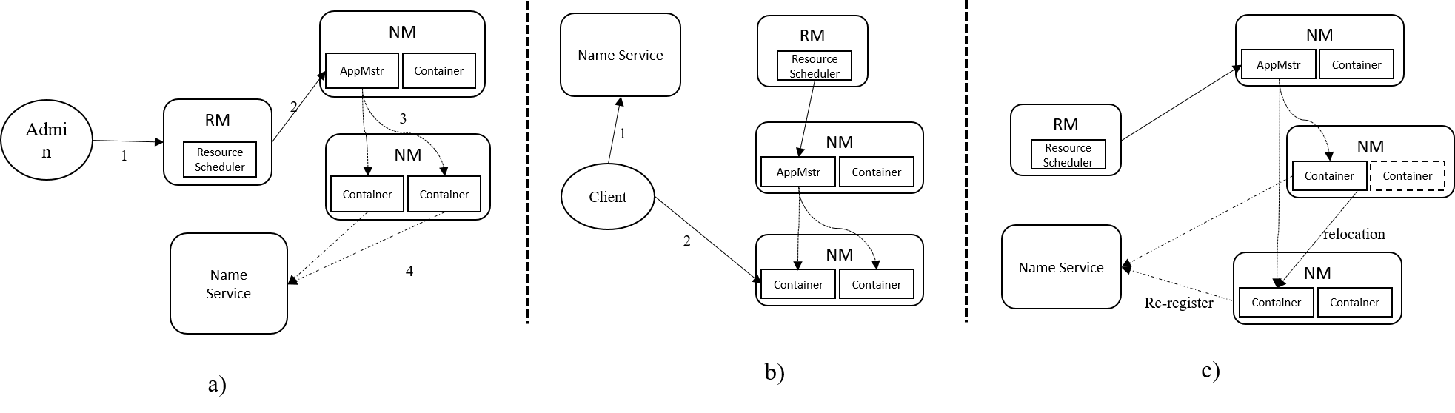
Figure 1. Architecture and workflow for long-lived services in YARN
Before we dive into details of our design, we need to address several basic concepts. Service is a potentially distributed application deployed in – or reachable from – a Apache YARN cluster (e.g. Apache Storm, Apache Spark). A Service Record is a record in the registry describing a service instance or a component instance. A component is a distributed element of a service (e.g. Storm Nimbus node). Endpoint is one means of binding with a service instance or a component instance (e.g. a Java JMX port on a region server). Endpoints can be both external – for use by programs other than service itself, and internal – for connecting components within the service instance.
Figure 1 illustrates the overall architecture and workflow we use to solve the service registry problem. Figure 1a shows the regular workflow when a new service was deployed. First the system administrator submits an request to deploy a new service. Second RM assigns corresponding resources to the cluster and launches the AM. Third, the AM starts containers with all the service’s components. Finally, the services which needed to interact with either internal or external clients will publish their service info to the name service. Figure 1b shows the regular workflow when an outside client wants to interact with the service. Basicly the client just asks the name service for the information he need and then use the right protocol to interact with the service.
We plan to use Zookeeper [7] as the base name service since it supports many of our required properties, then we pick a part of the Zookeeper namespace to be the root of the service registry (e.g. “<ZK-ROOT>/serviceRegistryRoot”).
We register every Service by binding a path to a value called a Service Record. The paths are hierarchical and use “/” as the root and “/” as the separator. All path elements must match that of a lower-case entry in a hostname path as defined in RFC1123 [8]. This makes the naming convention match that of DNS so that we have the option of accessing the namespace via DNS protocol. Every Service Record is registered as persistent znodes. This ensures that the record remains present during planned and unplanned outages of the service, on the assumption that client code is resilient to transient outages.
Each service instance’s Service Record lists the Endpoints for its various protocols exported by that service instance. Table 1 shows the detail of Service Record.
Table 1: Service Record detail
Name | Description
Id: string | YARN application or container ID (missing/empty for statically deployed services).
Description: string | Human-readable description
registrationTime: long | Unix timestamp
Persistence: int | Persistence policy
External: List<Endpoint> | A list of service endpoints for external callers
Internal: List<Endpoint> | A list of service endpoints for internal use within the service instance

The persistence attribute defines when a record and any child entries may be deleted. Table 2 shows the detail.
Table 2: persistence property
Policy # | Name | Policy
0 | Permanent | The record persists until removed manually.
1 | Cluster Restart | Remove when the YARN cluster is restarted. This does not mean on HA failover; it means after a cluster stop/start.
2 | Application | Remove when the YARN application defined in the id field terminates.
3 | Application Attempt | Remove when the current YARN Application attempt finishes
4 | Container | Remove when the YARN container in The ID field finishes
5 | Ephemeral | Automatic deletion when the session is closed/times out.

The policies which clean up when an application, application attempt or container terminates require the id field to match that of the application, attempt or container.
Based on this design, we should be able to address three major problems when dealing with long-lived services. First, we could exploit service endpoints from services deployed in YARN. Second, different components in a single service would be able to locate each other according to the internal Endpoint information registered in Service Record. Third, corresponding components would be able to find component information when an NM with that component relocates itself due to failure or other reasons.

Log Management
Figure 2 shows the workflow of YARN’s current approach to handle log aggregation. When AM wants to launch an application in NM, it sends a message to the Container Manager. Then the Container Manager will launch the corresponding application along with a specific log aggregation service attached to that application. Log Aggregation Service periodically checks if the application is finished or aborted, and if so, it starts to aggregate and transfer the logs of that application to the outside storage system (typically HDFS).
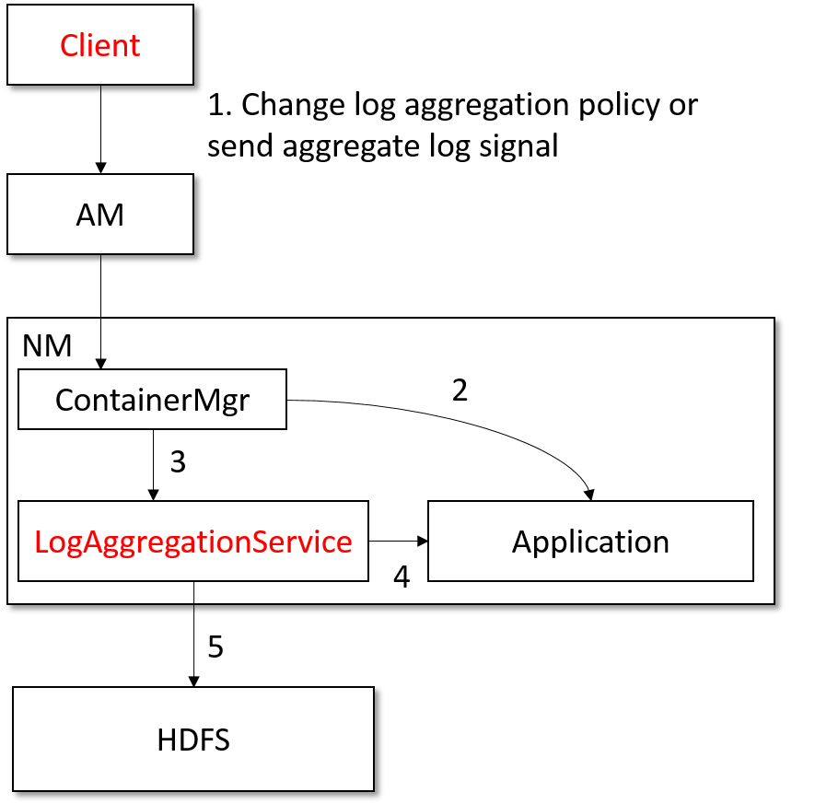
Figure 2. flow of YARN log aggregation
We provide a brand new LogAggregationService which could aggregate log based on different policies (time-based aggregation, size-based aggregation) for clients to choose. Other than that, we add new protocol to AM-NM communication which allows clients to send log aggregation signals to have NM aggregate application’s log immediately or send aggregation policy change signal to aggregate all application’s log into HDFS.

Dynamic change of container resource
The meaning of resource increase and resource decrease depends on what resource calculator is configured in YARN. Default resource calculator only compares memory, whereas dominant resource calculator uses dominant resource algorithm to compare multi-dimensional resources.
The high level flow of increasing and decreasing resource of an existing container is illustrated in Figure 4 and Figure 5.
The detail flow is described below:
- AM sends increase resource request to RM, specifying the container ID
- RM increases resource in the scheduler following the logic of allocating new containers
- Once the increase is granted, RM provides a new token to sign the granted increase
- AM sends increase request to NM, signed with the new token
- The ContainerManager updates the quota of this container in the ContainerMonitor
- The ContainerManager sends increase message to NodeStatusUpdater
- NodeStatusUpdater sends increase request to RMNode during NM/RM heartbeat
- RMNode sends increase message to the corresponding scheduler, which will verify the increase request
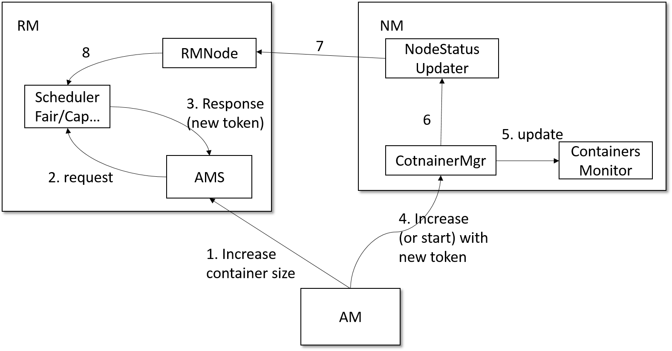
Figure 4. flow of increasing container resource (positive case)
The detail flow of decreasing container resource is described below:
- AM sends decrease resource request to NM
- The ContainerManager decreases monitoring quota in the ContainerMonitor
- The ContainerManager sends decrease message to NodeStatusUpdater
- NodeStatusUpdater sends decrease request to RMNode during NM/RM heartbeat
- RMNode sends decrease message to the corresponding scheduler
- RM informs AM about the change
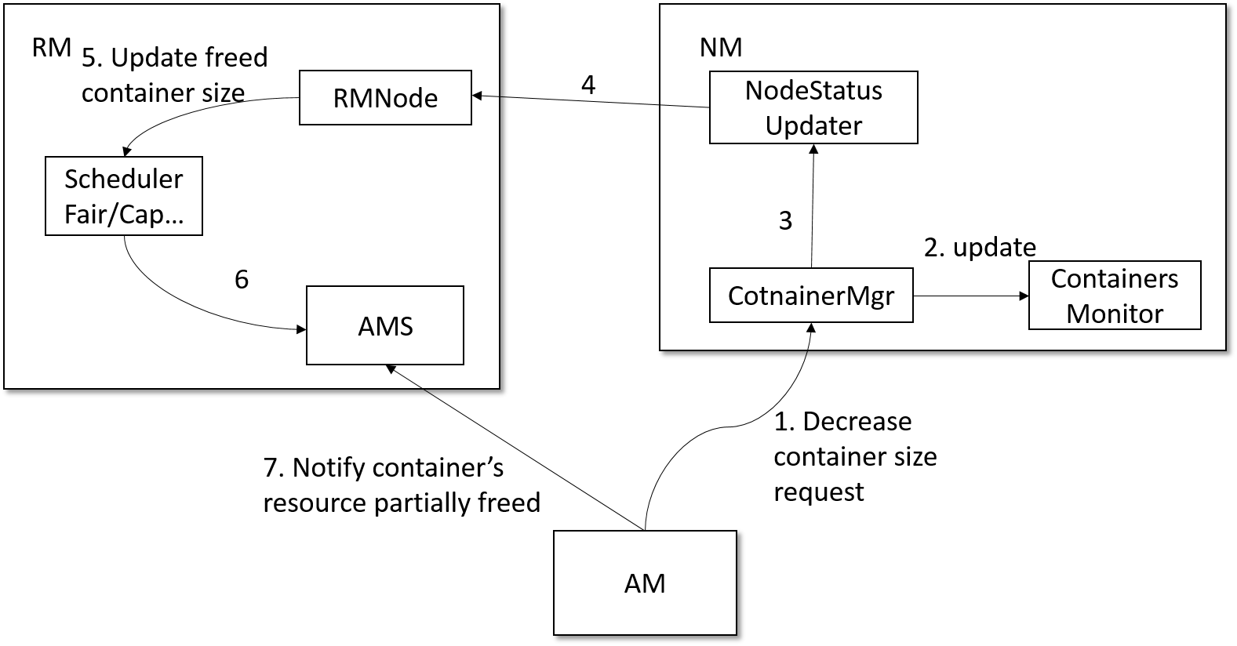
Figure 5. flow of decreasing container resource (positive case)
To simplify design and avoid race condition, only containers in RUNNING state can increase or decrease their resources. We do not support increase/decrease containers in ACQUIRED state because:
• Increase container resource requires a container token. If a container is in ACQUIRED state, it means the container is ready to be used, hence it is not reasonable to change the resource which was just allocated.
• Decrease container resource is initiated through ContainerManager on a NodeManager. If a container is not even started on a node, there is nothing to decrease.
With the flows of increasing/descreasing container resource defined, we did some adjustment on the Capacity Scheduler.
At each nodeUpdate action of Capacity Scheduler, RM will check the newlyChangedContainers data structure to check any unprocessed container increase or decrease messages coming from NM status update.
To process a valid resource decrease message, the scheduler will first check container resource in related metrics. If, as a result of the decrease, the container resource will go below the minimum allocation for each container specified in yarn-default.xml, it will be adjusted to the minimum allocation. After that, the scheduler will update the resource in container.
To process a valid resource increase message, the scheduler will do nothing except to issue an INCREASED event to notify ContainerResourceIncreaseExpirer to unregister the increase request.
After processing all resource change messages for a container in a node update, RM will set the current resource allocation known by RM for this container in the next node heartbeat response, so that NM will (eventually) have the same view of the resource allocation of this container as RM.

Evaluation
We now evaluate our approach. Specifically, we present experimental results that answer the following questions:
• Is our design successfully accommodate Apache-YARN to long-lived services?
• How does our design affect the short-lived services in YARN?
We evaluate the ability of our design to accommodate YARN to long-lived services using two sets of experiments. We first deploy a distributed stream engine Apache Storm to YARN, then we deploy a pool of Tomcat web servers to YARN. Using these two long-lived services, we were able to test if our solution actually solves service registration, log management, and container adjustment problem of YARN.

Long-lived services
We focus on two parts to test service registration: 1) Can we discover the existing Storm cluster? 2) What happens if some of Storm’s component fails?
For the first part, our design successfully discovers the existing Storm cluster with a little adjustment to Storm (using our API for each component to report critical information to the registration service). For the second part, we intentionally shutdown random nodes of our YARN cluster, and after the node relocation procedure finished, the cluster is recovered from failure and all the required entries appears our service registry.
We focus on two parts to test the log management function: 1) Can we change our aggregation policy after the cluster was deployed? 2) Can we aggregate logs whenever we want?
With our adjustment to LogAggregationService and Client’s API, we now are only one command away to do the two orders described above.

Affection on short-lived services
We evaluate our design’s affection on short-lived services by comparing the performance with the original version of YARN.
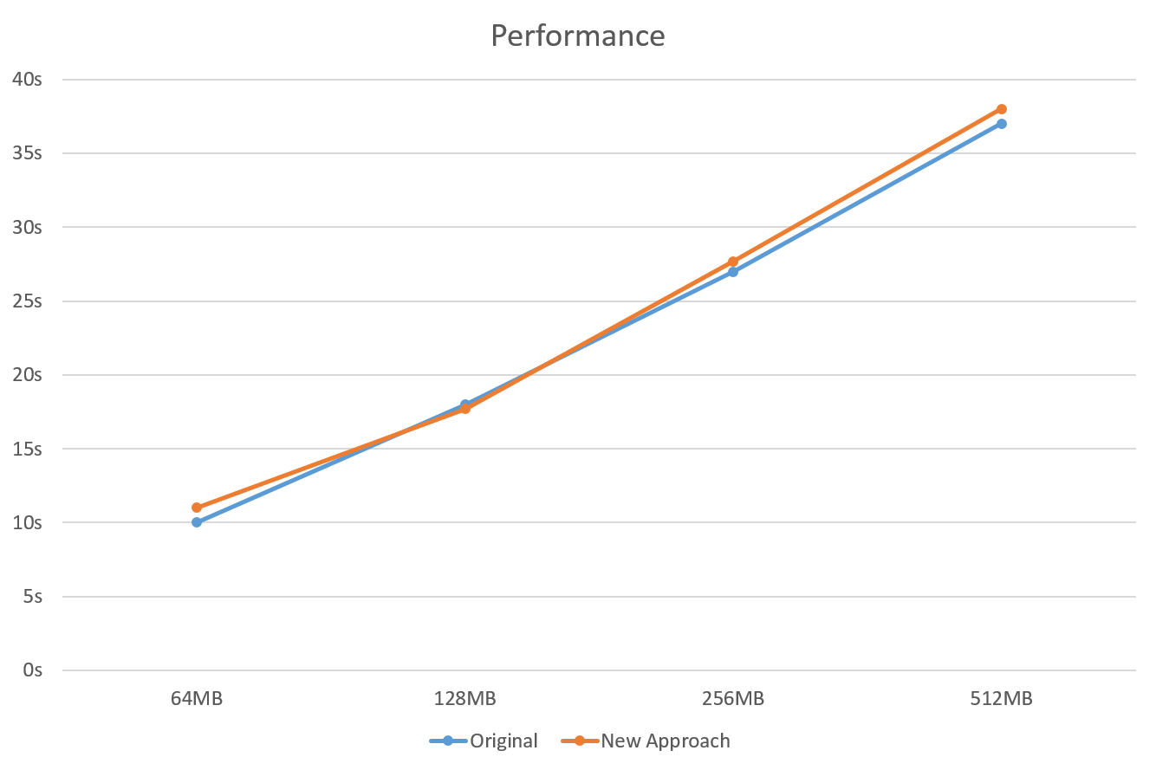
Figure 6: performance evaluation
Figure 6 illustrates the result. We use four different size of test data, and result shows that our approach didn’t bring any additional performance overhead to short-lived services.

Related work
In this section we describe the related work our design is based and other approaches to accommodate long-lived services to YARN.
Our design is mainly based on the work of Apache Slider [13], which is a project that aims to allow long-lived services to run on YARN cluster and minimizes the management trouble. Slider did this by add additional components and agents in Application Master and Node Manager which was used to track the deployed service information and allow changes with command line interface. Our approach uses zookeeper to exploit its strength on service registration instead of reinventing the wheel.
References
- Vavilapalli, Vinod Kumar, et al. "Apache hadoop yarn: Yet another resource negotiator." Proceedings of the 4th annual Symposium on Cloud Computing. ACM, 2013.
- Hindman, Benjamin, et al. "Mesos: A Platform for Fine-Grained Resource Sharing in the Data Center." NSDI. Vol. 11. 2011..
- Schwarzkopf, Malte, et al. "Omega: flexible, scalable schedulers for large compute clusters." Proceedings of the 8th ACM European Conference on Computer Systems. ACM, 2013.
- Verma, Abhishek, et al. "Large-scale cluster management at Google with Borg." Proceedings of the Tenth European Conference on Computer Systems. ACM, 2015.
- Corona facebook https://github.com/facebookarchive/hadoop-20/tree/master/src/contrib/corona.
- Sharma P P, Navdeti C P. Securing Big Data Hadoop: A Review of Security Issues, Threats and Solution[J]. IJCSIT) International Journal of Computer Science and Information Technologies, 2014, 5(2).
- Hunt, Patrick, et al. "ZooKeeper: Wait-free Coordination for Internet-scale Systems." USENIX Annual Technical Conference. Vol. 8. 2010.
- RFC1123: http://www.ietf.org/rfc/rfc1123.txt
- George, Lars. HBase: the definitive guide. " O'Reilly Media, Inc.", 2011.
- Toshniwal, Ankit, et al. "Storm@ twitter." Proceedings of the 2014 ACM SIGMOD international conference on Management of data. ACM, 2014.
- Zaharia, Matei, et al. "Spark: cluster computing with working sets." Proceedings of the 2nd USENIX conference on Hot topics in cloud computing. Vol. 10. 2010.
- Zaharia, Matei, et al. "Resilient distributed datasets: A fault-tolerant abstraction for in-memory cluster computing." Proceedings of the 9th USENIX conference on Networked Systems Design and Implementation. USENIX Association, 2012.
- Apache Slider: http://slider.incubator.apache.org/index.html.

 

